## DTX Polyfiller 2.0

I created [DTX Polyfiller 2.0](https://chrome.google.com/webstore/detail/dtx-polyfiller/mbdlbjpimeeemdhkehileedfdemdlogk) – An extension for Chrome to add a plethora of features, including: Chrome support, Highlighting bank holidays, auto-login, workdays selection via checkboxes (fills 7.5 hrs) and much more!

## About the tool

While on the bench, I wanted to improve the efficiency of Cap tools I’d have to regularly use. Initially, I used the app “TamperMonkey” to run custom code in my browser for sites like DTX. When colleagues saw and requested a copy, I researched better ways to distribute it and came across a similar project by Dan Cotton’s on [Capgemini’s GitHub](https://github.com/Capgemini). From here, I made a fork (copy) and began adding my own contributions.

I have since published my version of the tool to the Chrome store as a free browser extension; downloadable [here](https://chrome.google.com/webstore/detail/dtx-polyfiller-2/mbdlbjpimeeemdhkehileedfdemdlogk). It is currently used by over 70 Capgemini employees.

## Screenshots

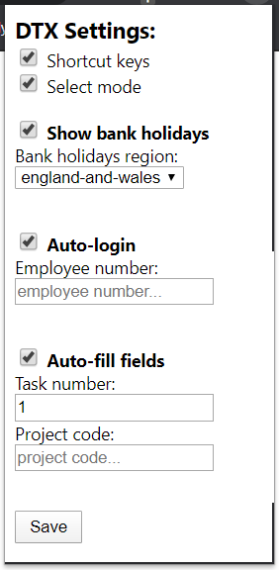 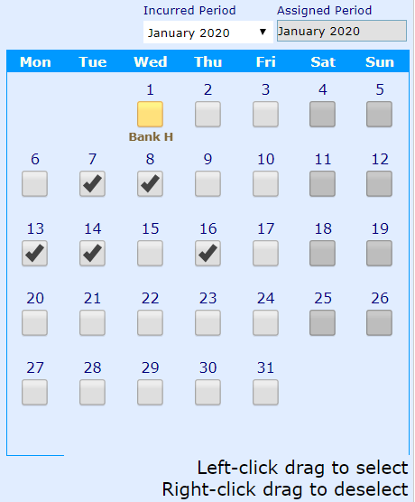

## Advice for starting similar projects

Study your (and your colleague’s) work processes, keeping an eye out for repetitive lengthy routines. If you find one, there’s a gap for time-saving automation someone can benefit from.

Similar project I’ve worked on:

* [VPNConnect](https://github.com/FreddieDev/VPNConnect/blob/master/README.md) – Connect to the Cap network offsite in one step
* [PasteyShortcuts](https://github.com/FreddieDev/PasteyShortcuts/blob/master/README.md) – Double press @ to paste your email and # for your employee number
* [TweetMirror](https://github.com/FreddieDev/TweetMirror/blob/master/README.md) – Auto-shares networking Tweets to MS Teams for colleagues to repost
* [Who’sTurn](https://github.com/FreddieDev/WhosTurn/blob/master/README.md) – A silly game: Players each hold a key to randomly select who makes the coffee